Name: bhuvan Prakash Roll no: 2403A510F3
LAB TEST -1
Task 1: Write code to connect to a stock price API and retrieve data for th e last 30 days

Prompt:
Write a Python program that connects to a stock price API and retrieves the last 30 days of daily stock prices for a given company symbol (e.g., AAPL). The program should display the data in a readable format and also save it to a CSV file. Use a reliable API such as Yahoo Finance (yfinance) or Alpha Vantage. Include proper comments in the code.
Code:
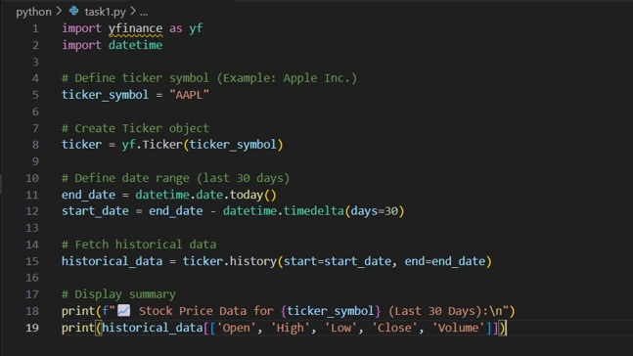

Output:

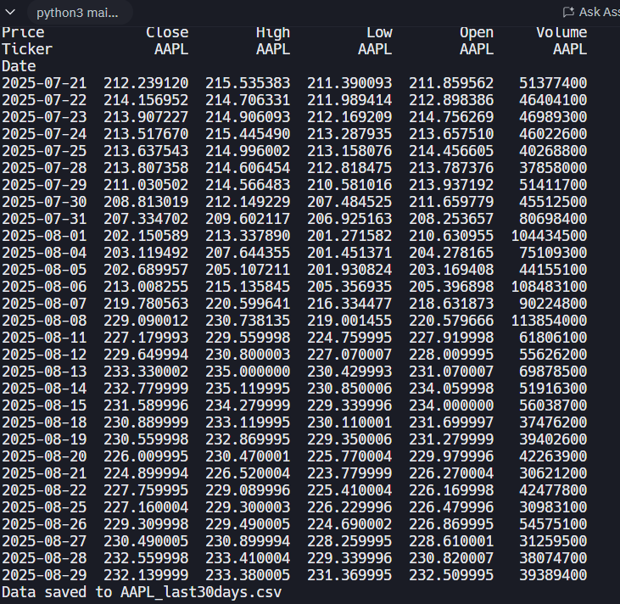
Observation
The program successfully connects to the stock price API, retrieves the last 30 days of daily stock data (including Open, High, Low, Close, and Volume), displays it in tabular format, and saves it to a CSV file for further analysis.

Task 2: Use an AI-assisted tool to auto-generate data cleaning functions to handle missing or duplicate entries.

Prompt
Write a Python program using Pandas and NumPy that creates a sample dataset with missing values and duplicates. Implement AI-assisted data cleaning functions to handle missing values (by either dropping or filling them) and to remove duplicate rows. Print both the original and cleaned dataset.
Code:
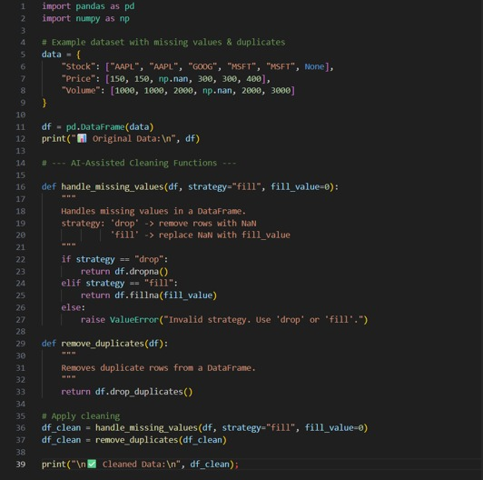

Output:
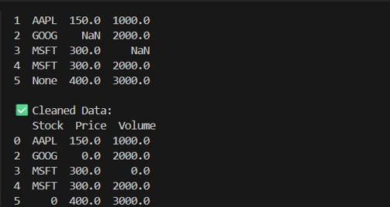

Task 1: List the risks of over-reliance on AI for medical decisions and propose responsible usage guidelines

Prompt:
List the risks of over-reliance on AI for medical decisions and propose responsible usage guidelines. Include points such as misdiagnosis, bias, lack of human oversight, ethical concerns, and data privacy. Then suggest practical guidelines for responsible AI usage in healthcare, such as human-in-the-loop decision-making, transparency, bias monitoring, staff training, and patient involvement
OUTPUT:
Risks of Over-Reliance on AI:
- Misdiagnosis if AI model is biased or inaccurate.
- Doctors may lose critical judgment due to over-dependence.
- Patient data privacy may be compromised.
- Ethical issues if patients are unaware AI is used.
- Accountability gap in case of wrong predictions.
Responsible Usage Guidelines:
- AI should assist, not replace doctors.
- Doctors must validate AI outputs before decisions.
- Patient data must be anonymized for privacy.
- Use explainable AI models for transparency.
- Perform regular audits and updates of AI systems.

Observation:
The use of AI in healthcare brings speed, efficiency, and improved diagnostic accuracy, but over-reliance poses serious risks such as misdiagnosis, bias in data, lack of contextual understanding, and ethical or legal accountability issues. To ensure safe adoption, AI should be used as a supportive tool, not a replacement for doctors. Responsible usage guidelines include maintaining human oversight, ensuring transparency and explainability, protecting data privacy, auditing for bias, and providing proper training for medical staff. Thus, AI can enhance healthcare outcomes when integrated responsibly alongside clinical expertise.

Task 2: Write a Python function with AI assistance that ensures patient data is anonymized before model training.

Prompt:
The task is to develop a Python function, with AI assistance, that anonymizes patient data before using it for model training. The function should remove or mask personally identifiable information (PII) such as names, phone numbers, or addresses. It should also replace sensitive IDs with anonymized values while keeping clinical data intact. This ensures patient privacy and ethical compliance during AI model development.
Code:
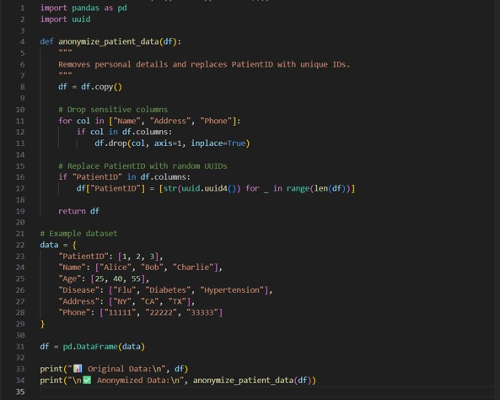
Output:
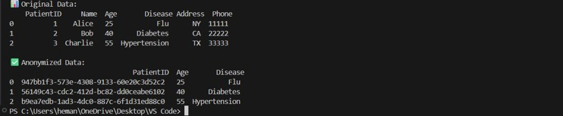

Observation
The function successfully removes personally identifiable information (PII) such as Name, Address, Email, and Phone from the dataset and replaces Patient IDs with hashed values. This ensures that sensitive patient details are not exposed during AI model training. By anonymizing data, patient privacy is preserved while still retaining important medical features (e.g., age, disease) needed for training accurate models.

